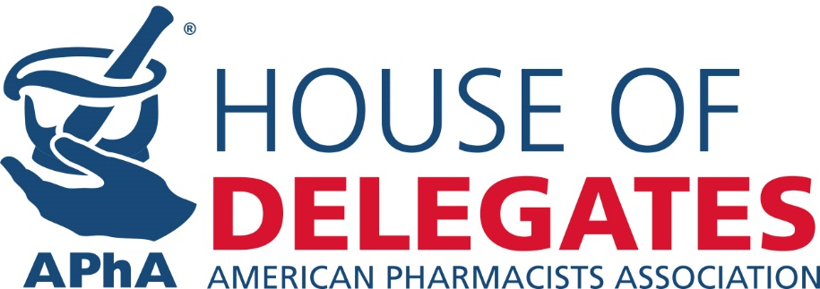

MEMORANDUM

To: Delegates & Alternate Delegates to the APhA House of Delegates
From: Theresa Tolle, Speaker of the APhA House of Delegates
Date: August 17, 2015
Subject: Second Report to the APhA House of Delegates

It is hard to believe that the first half of the calendar year has already gone by. As the Speaker of the House, one of my goals and responsibilities is to assist you in navigating your path as a delegate. Since our last meeting we worked to integrate your feedback and questions; I hope that you find the information in this message and future messages helpful in that regard. Please continue to communicate with me as we work to have a more efficient, informative and effective House meeting. Your active engagement is critical to our policy development process.

2015 Policy Development Process
Policy Topics for 2016: The Board of Trustees approved the following scope for topics that the Policy Committee and the 2016 House of Delegates will consider:
1) Biosimilar product selection/substitution by the pharmacist, education and training needs of pharmacists related to biotechnology and biosimilar products and other practice and patient care issues related to use of these products.
2) Point of care testing/Rapid diagnostic testing.
3) Medication management services implementation, terminology and components (including issues related to pharmacist’s patient care process and med sync).
These policy topics were derived from member comments and questions received following the House of Delegates in San Diego, CA. To get a better feel for the policy topics, review a brief synopsis of each topic here. The Policy Committee will use the information and feedback obtained from members to shape the proposed statements being presented to the House of Delegates.

To introduce and gain feedback on the topics, I will moderate two webinars related to the identified policy topics. I expect insightful and thoughtful discussion from the Policy Committee (October 16-18, 2015) and House sessions in Baltimore.

If you have comments for the committee’s deliberation, please email me at hod@aphanet.org.

Earn CPE Credit
The House of Delegates is constantly seeking innovative ways to engage our members. Once again, we will offer CE credit for delegate participation in educational webinars on the policy topics:
- Biosimilar product policy considerations, their impact on patient care and needs of pharmacists
(October 14, 1:00-2:00pm ET) – Moderated by XX (To be determined at a later time)
- Medication management services implementation, terminology and components (including issues related to pharmacist’s patient care process and med sync)
(October 15, 1:00-2:00pm ET) – Moderated by XX (To be determined at a later time)
- Point of care testing/Rapid diagnostic testing
(October 15 1:00-2:00pm ET) – Moderated by XX (To be determined at a later time)

Register for the webinars at http://www.pharmacist.com/apha-house-delegates.

Are you registered as a Year-Long Delegate?
Delegate appointments are now being processed for the 2016 House! We invite you to be an active participant in the Associations policy development process by contributing in discussions and sharing your views on issues impacting the pharmacy profession. If you are interested in becoming a delegate and representing your state association, APhA Academy leadership, or other recognized organizations, please let us know. Delegates are appointed to serve a one-year term (from June 1, 2015 through May 31, 2016). Visit the House webpage to learn more on how you can get involved.

*New* Delegate Toolkit
The APhA House of Delegates introduces a “Delegate Toolkit” as a resource to provide Delegates access to the most current and relevant information a delegate will need to prepare for his/her role. The goal of the toolkit is to help you navigate your role you as a delegate/alternate delegate and to help guide the work of the House of Delegates. If asked about your role as a delegate, you can use this resource to better explain the purpose of the House of Delegates and how active engagement in the policy process is essential to the policy process.

Please take some time to review the toolkit and provide us with feedback on items you would like to see added or revised.

New Business Review Committee Processes
I want to remind you of the procedure for submitting New Business Items. If you have a topic you wish to be considered as a New Business Item, you must submit the item to House staff 30 days before the start of the first House session (submit by February 3, 2016). New Business Items submitted after the deadline date will be accepted at the discretion of the Speaker, who will evaluate the urgency of the issue in question. To make sure delegates have ample time to consider your proposed New Business Item, I encourage you to submit as early as possible using the NBI Form.

Take a Leadership Role - Call for Candidates for Speaker-elect
The House of Delegates Committee on Nominations is seeking applications for the office of Speaker-elect. The Speaker-elect will be elected and installed during the 2016 Annual Meeting and will complete a three-year term through the 2019 Annual Meeting. The elected official will serve the first year as Speaker-elect and the subsequent remaining two years as Speaker and APhA Trustee.

If you are interested, candidate information must be received in the APhA House of Delegates office by March 3, 2016. Please review the qualifications, duties and nomination process found here.

House Launches Updated Website
The House is very excited to announce the release of our newly updated website, designed with a fresh new approach and user friendly navigation. The website features bright icons and an uncluttered design, as well as a new logo with short bulleted points to help you navigate from point A to B. We have taken significant time during this process to think through not only how we do business, but more importantly, what we believe is essential to our delegates and members.

As the legislative body of APhA, our goal is to make information sharing of delegate materials, committee reports and webinar opportunities as easily accessible as possible.

Delegate Material Availability and Distribution
After receiving your feedback, we are continuing to do our part to support conservation efforts by reducing paper waste, therefore, a limited number of printed Delegate Reference Materials will be available onsite. Delegate materials will be provided electronically prior to the meeting so please ensure that your email address is current. Delegates are encouraged to download the materials to their electronic devices or print them ahead of time.

The House of Delegates Reference Materials will be available in a downloadable form on the HOD website in February. The electronic Reference book will include multiple indexes and bookmarks for easy navigation using Adobe Acrobat Reader.

Over the course of the year, periodic reports will be posted on the House of Delegates web page to update you on the implementation of adopted policies and highlight associated activities. If you have any suggestions or questions regarding the House or the policy development process, please feel free to contact me or APhA staff directly at hod@aphanet.org. Thanks again for your participation and interest in the House of Delegates, and I look forward to working with you over the course of the year!

Sincerely,

Theresa Tolle, BPharm
APhA Speaker of the House of Delegates

Staff Liaisons:
Mitchel Rothholz, RPh, MBA, Chief Strategy Officer
Brian Wall, PharmD, Senior Manager, Governance
Wendy Gaitwood, Senior Administrative Manager, Policy & Governance

Online: http://pharmacist.com/apha-house-delegates Email: hod@aphanet.org

CC: Tom Menighan, BSPharm, MBA, ScD (Hon), FAPhA, Secretary of the APhA House of Delegates

