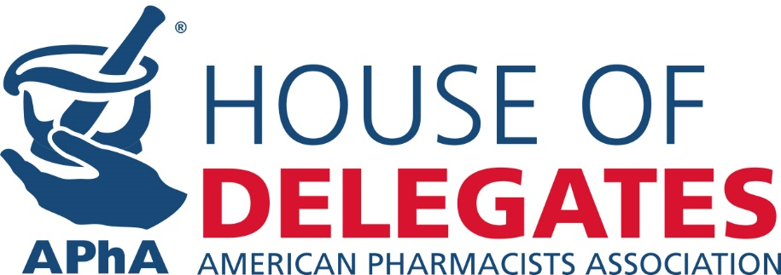

MEMORANDUM

To: Delegates & Alternate Delegates to the APhA House of Delegates
From: Theresa Tolle, Speaker of the APhA House of Delegates
Date: January 20, 2016
Subject: Fourth Report to the APhA House of Delegates

The 2016 House of Delegates meeting in Baltimore is fast-approaching! In preparation for the meeting, I am pleased to provide you with the status of the House Committees’ work so far. Our aim is to ensure that the policy development process and other responsibilities in the House of Delegates are clear and run as efficiently and effectively as possible. I have highlighted some important information to prepare you for your role as a delegate when attending the upcoming meeting.

2015 Policy Development Process

Each of the House Committees has been diligently working to complete their reports in preparation of APhA2016.

The Policy Committee discussed and developed 17 proposed policy statements related to Biologic, Biosimilar, and Interchangeable Biologic Drug Products, Point-of-Care Testing, and Medication Optimization Services. For more information please read the Policy Committee Report.

The House Rules Review Committee met via conference call to discuss 2016 House proceedings and to make recommendations for improvement of the overall operations of the APhA House. For more information please read the House Rules Review Committee Report.

The Policy Review Committee collectively reviewed 73 existing policy statements last reviewed in 2011 and 14 policy statements related to the policy topics assigned to the Policy Committee. For more information please read the Policy Review Committee Report.

All House Committee reports will be available at www.pharmacist.com/apha-house-delegates.

Action Required! Register for the 2016 House Sessions you Plan to Attend
Although you have been appointed by your delegations, we ask that you confirm your attendance for each of the House session(s) (Friday, March 4 and/or Monday, March7). Please indicate if you plan to attend the first session, second session, or both here.

Upcoming Webinar Opportunities!
We will provide webinars beginning mid-January to help you prepare for the House of Delegates. We strongly encourage you to participate in these webinars and provide your input on the direction of the Association’s policy.

Please use the links below to register.

- Policy Review Committee Overview (NEW - these webinar sessions replace the onsite Open Hearing)
  - Wednesday, February 3 from 6:00pm – 7:30pm EST or February 10 from 12:00 Noon – 1:30pm EST
- New Business Items
  - Wednesday, February 17 from 12 Noon – 1:30pm EST or February 24 from 7:00pm – 8:30pm EST
- Delegate Orientation Recording – Now Available Online (There will be no onsite session at APhA2016)

If you are unavailable to attend any of these or the previous sessions, all recordings will be archived and posted on the HOD website at http://www.pharmacist.com/apha-house-delegates.

LOOKING TO RUN FOR HOD SPEAKER-ELECT/SPEAKER: Call for Nominations–Submit Your Speaker-elect Nominations Today!
The House of Delegates Committee on Nominations is seeking applications for the office of Speaker-elect. The Speaker-elect will be elected and installed during the 2016 Annual Meeting and will complete a three-year term through the 2019 Annual Meeting. The elected official will serve the first year as Speaker-elect and the subsequent two years as Speaker and APhA Trustee.

If interested, please complete the nomination packet by February 25, 2016 so that an interview with the Committee on Nominations can be scheduled on Friday morning, March 4 (the official deadline for applications is March 3, 2016). Candidate information must be received in the APhA House of Delegates office by this deadline. Please review the qualifications, duties and nomination process here.

New Business Review Committee Processes: I want to remind you of the procedure for submitting New Business Items. If you have a topic you wish to be considered as a New Business Item, you must submit your item 30 days before the start of the first House session (by February 25, 2016). New Business Items submitted after the deadline date will be accepted only at the discretion of the Speaker and depending on the urgency of the issue in question. To make sure delegates have ample time to consider your proposed New Business Item, I encourage you to submit as early as possible using this NBI Form. Additional information relating to New Business can be found at http://www.pharmacist.com/apha-house-delegates.

Delegate Material Availability and Distribution
Delegate materials will be provided electronically prior to the meeting. Please ensure that your email address is current and that the HOD e-mail will get through your SPAM filter to receive alerts. Delegates to the 2016 House may request a print copy of the reference materials by completing a request form. The deadline to request a print copy is Friday, February 5, 2016.

PLANNING FOR THE 2017 HOUSE!

Potential Policy Topics
It’s never too early to plan ahead! In early April, APhA will begin the policy development process for 2017. With that in mind, I encourage you to begin thinking about the potential policy topics that should be addressed by the 2017 House of Delegates. Address the issues affecting you and your patient’s everyday by submitting emerging policy topics ideas before April, visit http://fs3.formsite.com/apha/form220/index.html to submit your ideas electronically.

Committee Volunteers Sought
On a related note, there are a number of opportunities for you to serve APhA on one of the House of Delegates committees. If you are interested in participating during the 2016-2017 policy development process, I encourage you to complete the committee volunteer interest form by June 15, 2016 at the following address: http://fs3.formsite.com/apha/form217/index.html.

Over the next few months, periodic reports will be posted on the House of Delegates web page to update you on the policy development process and highlight associated activities. I encourage you to check out these sites to familiarize yourself with the House of Delegate Reports and House-related events and activities provided in conjunction with the Annual Meeting.

Sincerely,

Theresa Tolle, BPharm
APhA Speaker of the House of Delegates

Staff Liaisons:
Mitchel Rothholz, RPh, MBA, Chief Strategy Officer
Brian Wall, PharmD, Senior Manager, Governance
Wendy Gaitwood, Senior Administrative Manager, Policy & Governance

Online: http://www.pharmacist.com/apha-house-delegates Email: hod@aphanet.org

CC: Tom Menighan, BSPharm, MBA, ScD (Hon), FAPhA, Secretary of the APhA House of Delegates

