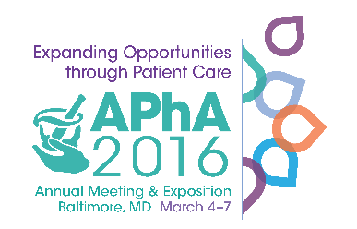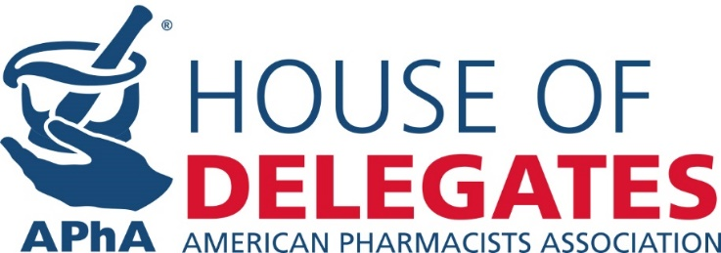

**Recap of House Session One – March 4, 2016**

**Action Taken During Session One**

The first session of the APhA2016 House of Delegates was a busy session with the House taking action on several items. Below is a snapshot of the action taken:

* Revisions to the **House Rules** were approved and utilized in the house session
  + No secondary amendments allowed
  + Policy Review Committee recommended statement amendments that change intent shall be submitted to the New Business Review Committee
* House received and approved the **Policy Review Committee** Report
* House received, began debate and took action on the **Policy Committee** Report. The following action was taken:
  + - **Biologic, Biosimilar and Interchangeable Biologic Drug Products:**
      * Statements Number 1, 2, 4, and 5 were adopted
      * Statement Number 3 was referred to the Policy Reference Committee
  + **Point-of-Care Testing**:
    - * Statement Number 3 was adopted
      * Statements Number 1, 2, 4, 5 and 6 were referred to the Policy Reference Committee
  + **Medication Optimization Services within the Patient Care Process**:
    - * Statements Number 1, 2, 3, 4, 5 and 6 were referred to the Policy Reference Committee

**Speaker of the House Elections Underway**

The process to select the next Speaker-elect got underway. The House will consider the following individuals:

* Collin Conway
* Michael Hogue
* Joey Mattingly

**Speaker Tolle Discusses “A Legacy of Leadership”**

In APhA Speaker of the House Theresa Tolle’s speech to the 2016 APhA House of Delegates she discussed the impact of APhA House policy on the profession, association and society. She recognized the impact of recently deceased Former Speaker Mary Louise Anderson and the House’s responsibility of “setting the course”, and while that is not always popular, it is CRITICAL and visionary! [Click here to read Speaker Tolle's speech.](http://www.pharmacist.com/sites/default/files/2016%20APhA%20Speaker%20of%20the%20House%20Address_Tolle_A_Legacy_of_Leadership%20-%20FINAL.pdf)



**Voting for APhA Board of Trustees and Academies Now Open**

Visit www.pharmacist.com/apha-elections for more information

The House heard from the candidates running for the APhA Board of Trustees at the first House Session. At 5:00pm ET the election polling was opened. You can cast your ballot utilizing your computer, smart device or visiting one of the voting booths located on APhA Main Street during the meeting. Voting will be open until noon EST on May 2, 2016.

**Talk to the candidates at “Meet the Candidates” on Monday, March 7 from 12:15pm-1:15pm** in the Convention Center Pratt Street Lobby. Go to <http://pharmacist.com/apha-elections> to read about the candidates for office.

**Engage in the Open Hearings**

The House Committees will hold the following Open Hearings prior to determining their recommendations to be presented to the APhA House of Delegates. This is an opportunity for any APhA meeting attendee to provide their feedback.

**New Business Review Committee Open Hearing**

**Saturday, March 5:** 1:00 pm – 2:30 pm Room 343/344

**Policy Committee Open Hearing** UNDAY, RCH 6

**Sunday, March 6:** 1:00 pm – 3:00 pm Room 343/344

MONDAY, MARCH 7

**Note: Final Session of the House is on Monday, March 7** 1:30 pm – 4:30 pm Room 307 – 310 - please check in and pick-up voting key pads at least by **1:00pm** (be seated by 1:15pm)

Delegate Check-in **begins at 11:00am** outside of Room 310

**House of Delegates Office Hours**

**- Room 311**

Thursday, March 3 3:00 pm – 6:00 pm

Friday, March 4 7:30 am – 3:00 pm

Saturday, March 5 8:00 am – 3:00 pm

Sunday, March 6 8:00 am – 3:00 pm

Monday, March 7 7:30 am – 1:00 pm