Example Informed Consent for

Medication Administration Services

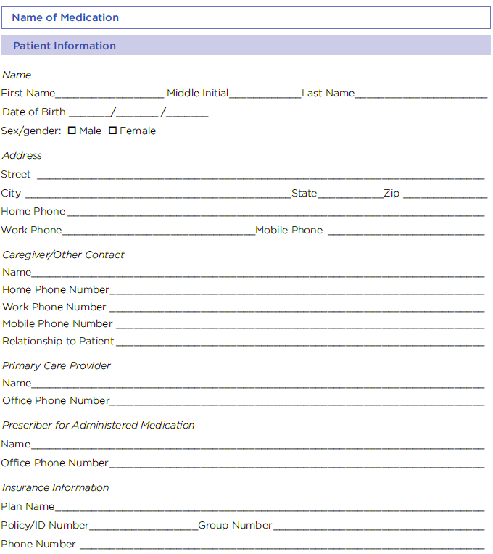

By my signature below, I consent to the administration of the prescribed medication by a pharmacist or a supervised student pharmacist, where permitted by law, and to be contacted at the phone number provided above regarding this pharmacy service. I also release the pharmacy and agents from all liability, including acts of omission or commission, resulting or arising from my receipt of this medication. I understand that:

- I have voluntarily chosen to receive the medication.
- I am of legal age and authorized to execute this consent form.
- I will immediately alert the pharmacist and the prescribing physician of any medical conditions which may adversely affect my personal health or effectiveness of the medication.
- I have received education about potential side effects of the medication, when they may occur, and when and where I should seek treatment. I understand that if I experience any side effects, I am responsible for following up with my prescriber at my expense.
- I have had the opportunity to ask questions about the medication, and all my questions have been answered. I understand the benefits and risks of the medication.
- I understand that my receipt of this medication is subject to reporting, by my pharmacy or its business associate, to my primary care physician, the prescribing physician, and/or the manufacturer, if required, and I authorize these disclosures.
- I authorize the pharmacy to bill my insurance provider for services.
- I understand that a copy of my medical records will be stored in a confidential manner.

