Example Medication Administration

Services Information Sheet for Patients

Medication Administration Services Available Here

Are you uncomfortable administering your medication or unable to visit your clinic for support?

We offer in-store medication administration services. Take advantage of our convenient location and hours to receive your medication from our highly trained pharmacists.

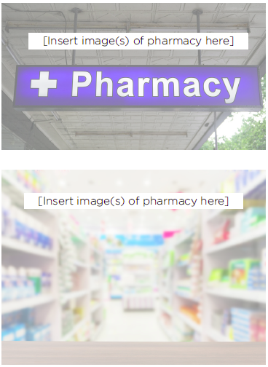
Benefits include:
- Convenient access to care, including nearby pharmacy locations and timely options for care

- Stigma-free environment

- Comfortable and private environment

- Administration of medication by our trained and knowledgeable pharmacists

- Individualized, patient-centered plan in collaboration with your other health care providers and caregivers

- Education and support to achieve treatment and lifestyle goals

- Care continuity, including follow-up and transitions of care

