Example Follow-up Letter From

Pharmacist to Prescriber

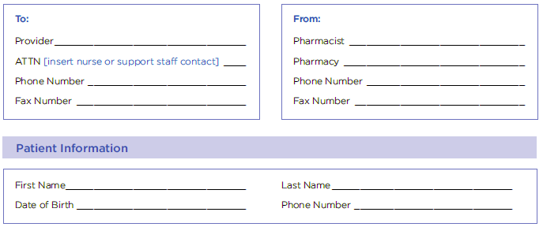

Date:____________________________

Dear Provider,

This letter is in regard to our mutual patient [patient’s name], who recently visited our pharmacy to receive [medication name] in accordance with your prescription order. [Insert pharmacy name] will work with our patient to help promote medication adherence and monitor for any adverse events. Any adverse events or other issues will be communicated to you.

Please note the following record of administration:
- [Insert medication name/dose]
- [Insert date of administration]/[insert time of administration]
- [Insert anatomical site of administration for injectable medications]

Thank you for your willingness to maintain open lines of communication to optimize [patient’s name] medication therapy. Please feel free to contact me at the phone number above if you have any questions.

Signature

