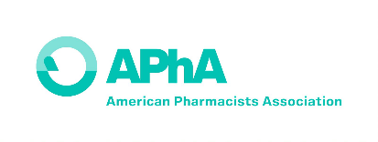
APhA Academy of Student Pharmacists
Chapter Achievement Awards Program

APPENDIX A – Reporting COVID-19

The COVID-19 pandemic has impacted the operations and events of APhA-ASP Chapters across the country. APhA-ASP Staff and the Awards Standing Committee are aware of the impact and the concerns regarding reporting of activities cancelled and/or limited due to the COVID-19 restrictions. The committee is especially excited to hear how chapters have adapted to the current situation and continued to carry out operations and the benefit to the community. Please include details about what changes and restrictions your chapter (including variations across campus and the state) faced, and all activities directly related to COVID-19 outreach in Section 3. APhA-ASP Chapters are encouraged to discuss any operational changes that allowed your chapter to continue engaging members and impacting patients.
The APhA-ASP Awards Standing Committees recommends the following:
- Chapters should include planned events that were impacted by COVID-19 in the “Chronological List” uploaded with their report. In the “Synopsis” section of the “Chronological List”, indicate if the event was fully established, still in the planning process, or cancelled.
- For any events that were completed, be sure to include how events may have been adapted or modified to meet the requirements of COVID-19 restrictions. (For example, hosting virtual chapter officer elections.)
- “Virtual” events and activities are those that were conducted via phone, social media stream, online meeting platform, etc.
- “Live” events and activities are those that were conducted in person at a physical location.
- “Hybrid” events and activities are those that were conducted as a combination of a “live” and “virtual” component.
- Remember, the goal of the Chapter Achievement Report is to celebrate and recognize the impact your chapter has had through events and experiences implemented in the community.
The APhA-ASP Awards Standing Committee and APhA staff are available to assist with any questions you may about reporting these events. Contact information for the committee is:
APhA Staff
Carly Harsha, PharmD
Senior Manager, Student & New Practitioner Development
charsha@aphanet.org
202-223-7193 (O)
APhA–ASP Awards Standing Committee
Chair: Aly York
Member: Becca Bruning
Member: Cassye Marsh
Member: Connor Anderson

